

# 

### Semester Two Examination, 2017

### Question/Answer booklet

# MATHEMATICS

If required by your examination administrator, please place your student identification label in this box

**APPLICATIONS**

**UNITS 3 AND 4**

## Section Two:

## Calculator-assumed

|  |  |  |  |  |  |  |  |  |  |  |
| --- | --- | --- | --- | --- | --- | --- | --- | --- | --- | --- |
| Student Number: In figures |  |  |  |  |  |  |  |  |  |  |

**Maths Teacher**

**Your name**

## Time allowed for this section

Reading time before commencing work: ten minutes

Working time: one hundred minutes

## Materials required/recommended for this section

***To be provided by the supervisor***

This Question/Answer booklet

Formula sheet (retained from Section One)

***To be provided by the candidate***

Standard items: pens (blue/black preferred), pencils (including coloured), sharpener, correction fluid/tape, eraser, ruler, highlighters

Special items: drawing instruments, templates, notes on two unfolded sheets of A4 paper, and up to three calculators approved for use in this examination

## Important note to candidates

No other items may be taken into the examination room. It is **your** responsibility to ensure that you do not have any unauthorised material. If you have any unauthorised material with you, hand it to the supervisor **before** reading any further.

## Structure of this paper

|  |  |  |  |  |  |
| --- | --- | --- | --- | --- | --- |
| Section | Number of questions available | Number of questions to be answered | Working  time (minutes) | Marks available | Percentage of examination |
| Section One:  Calculator-free | 7 | 7 | 50 | 52 | 35 |
| Section Two:  Calculator-assumed | 12 | 12 | 100 | 98 | 65 |
|  | | |  | **Total** | 100 |

|  |  |  |
| --- | --- | --- |
| Markers use only | | |
| Question | Maximum | Mark |
| 8 | 5 |  |
| 9 | 9 |  |
| 10 | 8 |  |
| 11 | 12 |  |
| 12 | 10 |  |
| 13 | 8 |  |
| 14 | 7 |  |
| 15 | 9 |  |
| 16 | 9 |  |
| 17 | 6 |  |
| 18 | 6 |  |
| 19 | 6 |  |
| S2 Total | 98 |  |
| S2 Wt (×0.6633) | 65% |  |

## Instructions to candidates

1. The rules for the conduct of examinations are detailed in the school handbook. Sitting this examination implies that you agree to abide by these rules.

2. Write your answers in this Question/Answer booklet.

3. You must be careful to confine your response to the specific question asked and to follow any instructions that are specified to a particular question.

4. Additional working space pages at the end of this Question/Answer booklet are for planning or continuing an answer. If you use these pages, indicate at the original answer, the page number it is planned/continued on and write the question number being planned/continued on the additional working space page.

5. Show all your working clearly. Your working should be in sufficient detail to allow your answers to be checked readily and for marks to be awarded for reasoning. Incorrect answers given without supporting reasoning cannot be allocated any marks. For any question or part question worth more than two marks, valid working or justification is required to receive full marks. If you repeat any question, ensure that you cancel the answer you do not wish to have marked.

6. It is recommended that you do not use pencil, except in diagrams.

7. The Formula sheet is not to be handed in with your Question/Answer booklet.

Section Two: Calculator-assumed 65% (98 Marks)

This section has**twelve (****12)** questions. Answer **all** questions. Write your answers in the spaces provided.

Working time: 100 minutes.

Question 8 (5 marks)

The scatterplot below shows the daily sales of take-away coffees on the -axis and canned drinks on the -axis for a market stall.

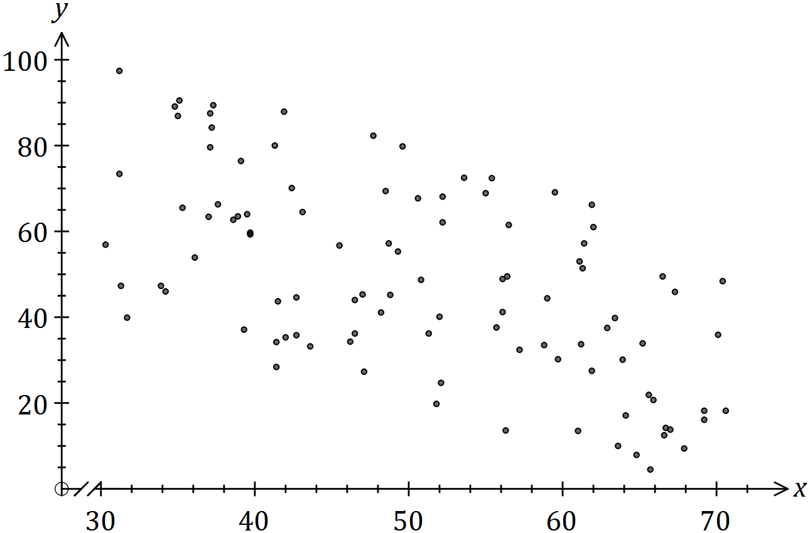

(a) Describe the association between the variables in terms of strength and direction.

(2 marks)

(b) The equation of the least-squares line that fits the data is . Interpret the slope of this line. (2 marks)

(c) Identify a possible non-causal explanation for the association between the variables.

(1 mark)

Question 9 (9 marks)

A researcher sought to determine whether a person's support for a particular political party affected their approval of a proposal to expand the Snowy Hydro scheme.

|  |  |  |  |  |
| --- | --- | --- | --- | --- |
|  | Vote Labour | Vote Lib/Nat | Vote other | Total |
| Approve |  |  |  |  |
| Disapprove |  |  |  |  |
| Don't know |  |  |  |  |
| Total |  |  |  |  |

(a) Complete the three missing entries in the table above. (2 marks)

(b) State which is the response variable and which is the explanatory variable. (2 marks)

(c) Explain why creating a table of column percentages, rather than row percentages, is appropriate in this instance. (1 mark)

(d) Complete the table of column percentages below. (2 marks)

|  |  |  |  |
| --- | --- | --- | --- |
| % | Vote Labour | Vote Lib/Nat | Vote other |
| Approve |  |  |  |
| Disapprove |  |  |  |
| Don't know |  |  |  |
| Total |  |  |  |

(e) Comment, with reasons, on whether any evidence exists to suggest that a person's support for a particular political party affected their approval of the proposal to expand the Snowy Hydro scheme. (2 marks)

Question 10 (8 marks)

A student was asked to estimate the length of lines generated at random on a computer screen. The actual and estimated lengths, in cm, are shown in the graph and table below.

|  |  |  |  |  |  |  |  |  |  |  |  |
| --- | --- | --- | --- | --- | --- | --- | --- | --- | --- | --- | --- |
| Actual length, | 5 | 12 | 11 | 14 | 8 | 10 | 18 | 16 | 6 | 15 | 20 |
| Estimated length, | 10 | 9 | 14 | 11 | 7 | 11 | 20 | 13 | 9 | 17 | 18 |

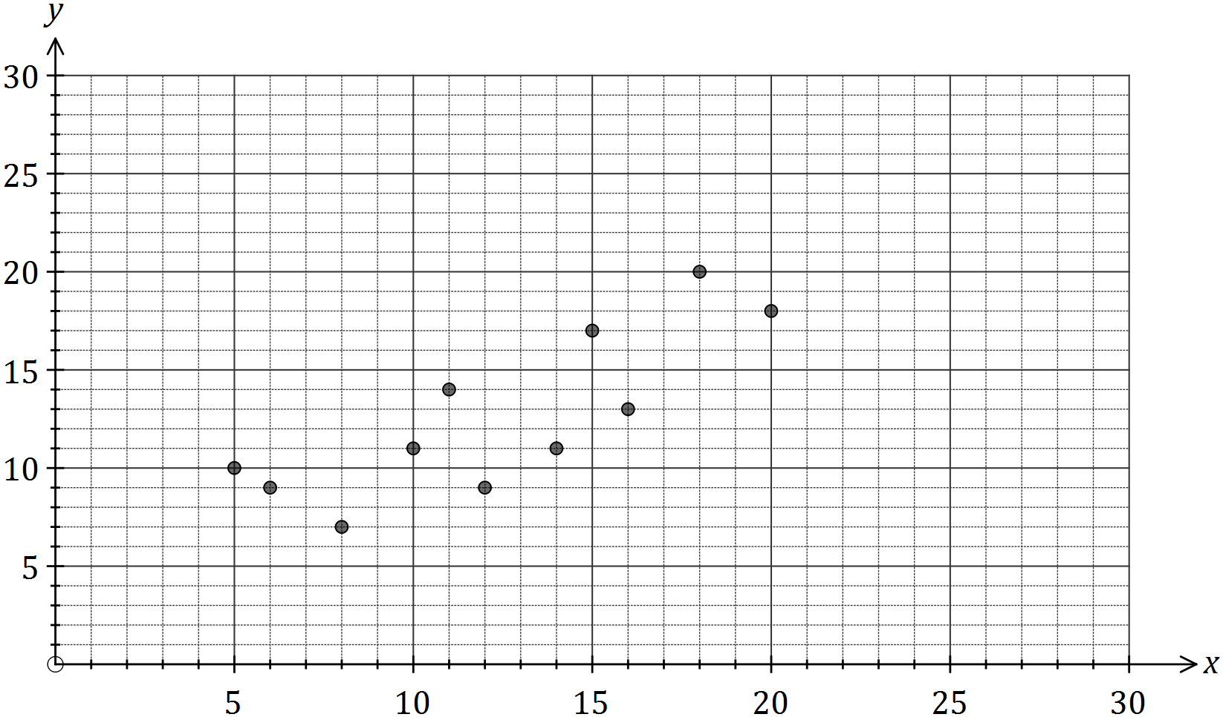

(a) Calculate the correlation coefficient between the variables and . (1 mark)

(b) A least-squares line can be used to model the relationship between and .

(i) Determine the equation of this line. (2 marks)

(ii) Draw this line on the graph. (2 marks)

(c) Predict the student's estimate, to the nearest cm, when the actual length of the line was 24 cm and comment on factors affecting the reliability of this prediction. (3 marks)

Question 11 (12 marks)

Every afternoon, 25 litres of water is taken from a tank and poured into a small garden pond. At the start of the first day the tank contains 300 L and the pond contains 40 L.

The amount of water in the tank at the start of day is given by .

(a) Complete the table below. (1 mark)

|  |  |  |  |  |  |  |  |  |
| --- | --- | --- | --- | --- | --- | --- | --- | --- |
|  |  |  |  |  |  |  |  |  |
| (L) | 300 | 275 |  |  |  |  |  |  |

(b) Deduce a rule for the amount of water in the tank at the start of the th day. (2 marks)

(c) Graph the amount of water in the tank at the start of day on the axes below. (2 marks)

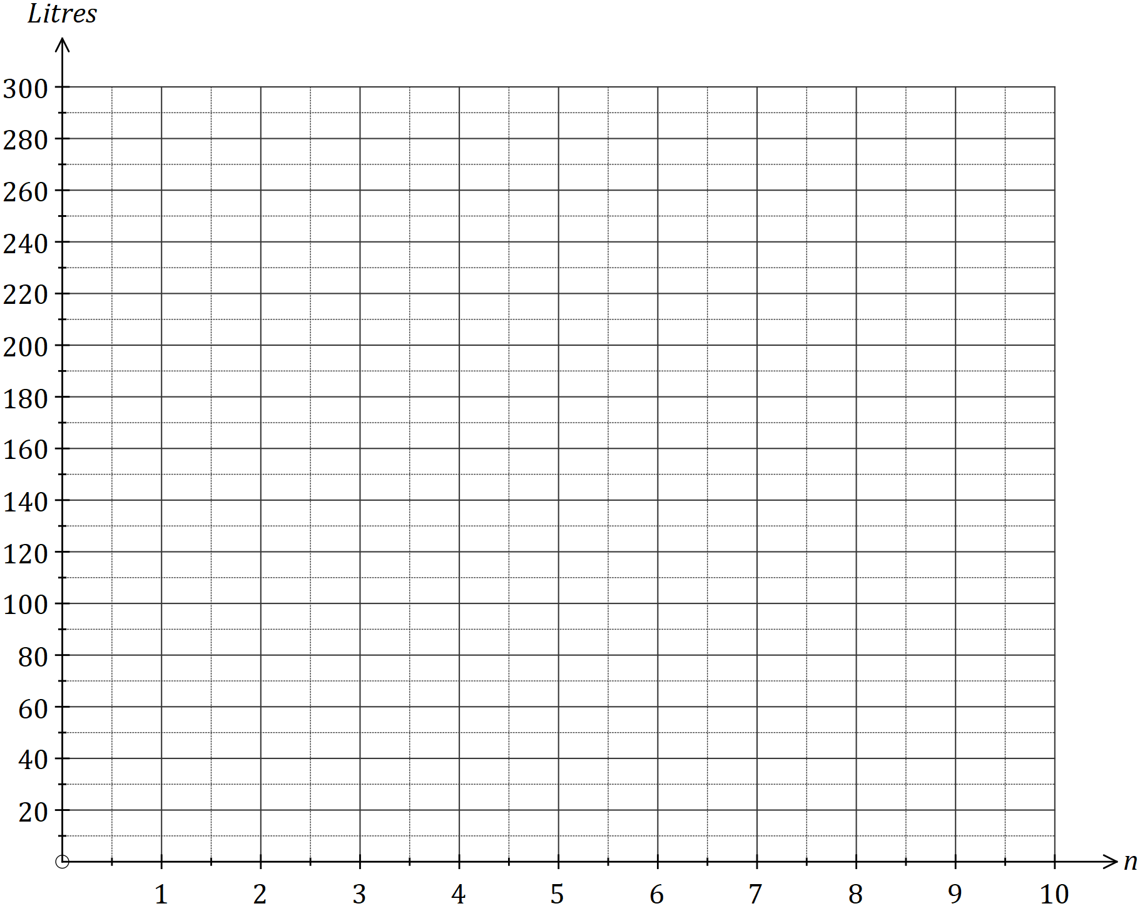

Due to the combined effects of evaporation and water being added from the tank, the amount of water in the pond, in litres, at the start of day is given by

(d) Complete the table below, writing all amounts to the nearest litre. (2 marks)

|  |  |  |  |  |  |  |  |  |
| --- | --- | --- | --- | --- | --- | --- | --- | --- |
|  |  |  |  |  |  |  |  |  |
| (L) |  |  |  |  | 90 | 97 | 103 | 107 |

(e) Add the amount of water in the pond at the start of day to the graph in (c). (2 marks)

(f) At the start of which day did the amount of water in the pond first exceed the amount of water in the tank? (1 mark)

(g) Determine the maximum amount of water in the pond and when this occurs.

(2 marks)

Question 12 (10 marks)

The number of page views, in thousands, of an international website were recorded in the morning (4 am to noon), afternoon (noon to 8 pm) and night (8 pm to 4 am) over several consecutive days.

|  |  |  |  |
| --- | --- | --- | --- |
| Day | Period | Time, | Page views, , (000's) |
| Mon | Morning | 1 | 5.6 |
|  | Afternoon | 2 | 4.4 |
|  | Night | 3 | 5.1 |
| Tue | Morning | 4 | 5.7 |
|  | Afternoon | 5 | 4.7 |
|  | Night | 6 | 5.5 |
| Wed | Morning | 7 | 5.9 |
|  | Afternoon | 8 | 4.6 |
|  | Night | 9 | 5.4 |
| Thu | Morning | 10 | 6.0 |
|  | Afternoon | 11 | 4.8 |
|  | Night | 12 | 5.6 |
| Fri | Morning | 13 | 5.4 |
|  | Afternoon | 14 | 4.9 |
|  | Night | 15 | 5.7 |

(a) Use the above data to complete the time series plot on the axes below. (2 marks)

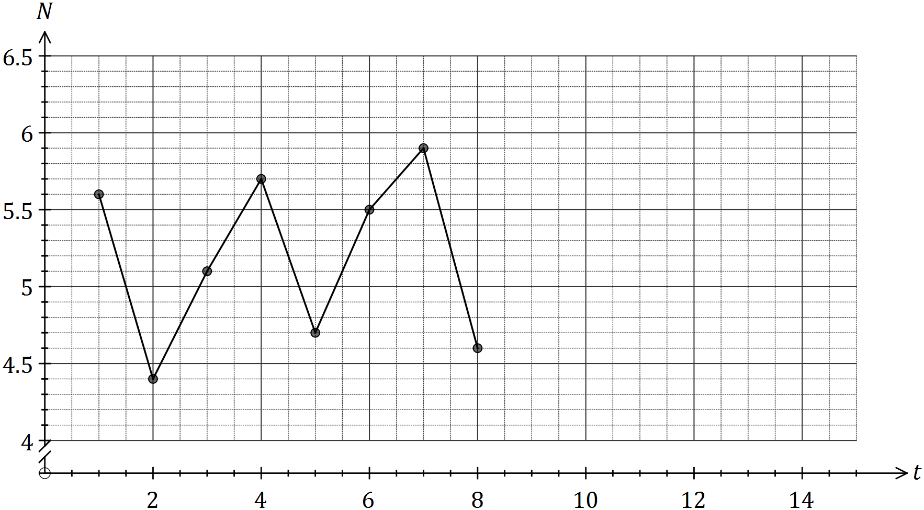

(b) One of the data points was suspected of being an outlier. Circle this point on the graph and explain why you chose it. (2 marks)

(c) Describe the trend and seasonality of the time series plot. (2 marks)

(d) Calculate the number of page views representing

(i) the three-point moving average for Tuesday afternoon. (2 marks)

(ii) the six-point centred moving average for Wednesday night. (2 marks)

Question 13 (8 marks)

A business took out a loan of $7 500 and made monthly repayments of $390. The table below shows the progress of the loan for the first few months, with repayments and interest applied at the end of each month.

|  |  |  |  |  |
| --- | --- | --- | --- | --- |
| Month | Balance at start of month | Interest | Repayment | Balance carried forward to start of next month |
| 1 | 7 500.00 | 60.00 | 390.00 | 7 170.00 |
| 2 | 7 170.00 | 57.36 | 390.00 | 6 837.36 |
| 3 | 6 837.36 |  | 390.00 |  |

(a) Determine the monthly interest rate. (1 mark)

(b) The recurrence relation to model the loan balance, , in the second column of the table is . State the values of and . (2 marks)

(c) Determine the values of and in the table. (2 marks)

(d) Calculate the balance of the loan at the start of month 5. (2 marks)

(e) If the business decreased the amount of each repayment, comment on how this would change the total interest accumulated over the life of the loan. (1 mark)

Question 14 (7 marks)

A retiree plans to start a pension fund with $750 000 and then withdraw an annuity of $55 000 one year later and then at subsequent yearly intervals. The fund is expected to grow at a rate of 5.4% per annum.

(a) Write a linear recurrence relation to model the total amount in the pension fund, , directly after the th withdrawal. (3 marks)

(b) Determine the number of years that the retiree can withdraw $55 000. (2 marks)

(c) Determine how much can be withdrawn each year if the retiree only wants the fund to last for 10 years. (2 marks)

Question 15 (9 marks)

The number of false alarms received by a monitoring station each quarter over the past three years is shown in the graph and table below.

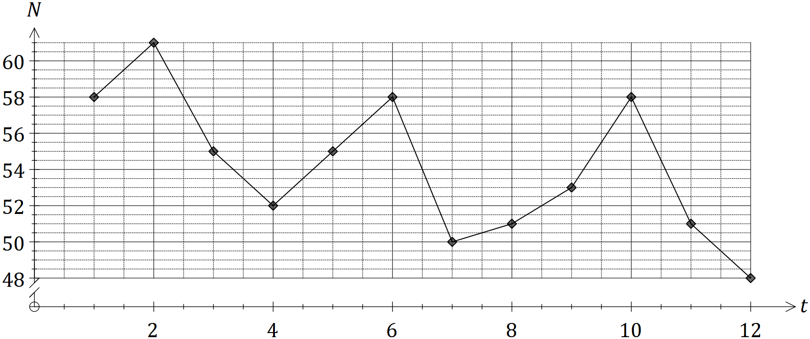

|  |  |  |  |  |  |
| --- | --- | --- | --- | --- | --- |
| Year | Quarter | Time period  (t) | Number of false alarms () | Yearly  mean | Percent of yearly mean |
| 2014 | 1 | 1 | 58 | 56.5 | **A** |
| 2 | 2 | 61 | 108.0 |
| 3 | 3 | 55 | 97.3 |
| 4 | 4 | 52 | 92.0 |
| 2015 | 1 | 5 | **B** | 53.5 | 102.8 |
| 2 | 6 | 58 | 108.4 |
| 3 | 7 | 50 | 93.5 |
| 4 | 8 | 51 | 95.3 |
| 2016 | 1 | 9 | 53 | **C** | 101.0 |
| 2 | 10 | 58 | 110.5 |
| 3 | 11 | 51 | 97.1 |
| 4 | 12 | 48 | 91.4 |

(a) Calculate the values of the entries **A**, **B** and **C** in the table. (3 marks)

(b) Three of the four seasonal indices, calculated using the average percentage method, are shown in the table below. Calculate the missing index for quarter 3 and interpret its value. (2 marks)

|  |  |  |  |  |
| --- | --- | --- | --- | --- |
| Quarter | 1 | 2 | 3 | 4 |
| Seasonal index | 1.02 | 1.09 |  | 0.93 |

(c) Calculate the deseasonalised number of false alarms for the fourth quarter of 2015.

(1 mark)

(d) The equation of the least-squares line to forecast the deseasonalised number of false alarms, , is .

Forecast the **actual** number of false alarms in the second quarter of 2018, assuming that the above seasonality and trends continue. (3 marks)

Question 16 (9 marks)

The tasks involved in a construction project are shown in the table below.

|  |  |  |  |  |  |  |  |  |  |
| --- | --- | --- | --- | --- | --- | --- | --- | --- | --- |
| Task | A | B | C | D | E | F | G | H | J |
| Duration  (days) | 5 | 8 | 9 | 7 | 8 | 10 | 2 | 11 | 6 |
| Immediate predecessors | - | A | A | B | B | C | D, E, F | C | G, H |

(a) Complete the project network below. (3 marks)

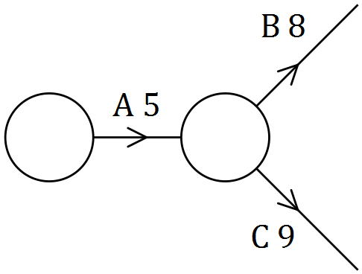

(b) List the tasks on the critical path and state the minimum completion time for the project.

(2 marks)

(c) If the project is completed in the minimum possible time, determine

(i) the earliest start time for task E. (1 mark)

(ii) the latest start time for task B. (1 mark)

(iii) the task with the largest float time, and what this float time is. (2 marks)

Question 17 (6 marks)

A competition winner set up a fund on January 1, 2016, with their prize of $500 000. The balance of the fund grew at an annual rate of 3.3%, compounded monthly. Starting on February 1, 2016, the winner withdrew $950 from the fund on the first day of each month.

(a) Determine the balance in the fund just after the withdrawal was made on January 1, 2017.

(2 marks)

(b) Determine the total amount of interest accrued by the fund during 2016. (2 marks)

(c) From January 1, 2017, the annual interest rate applying to the fund decreased and the winner found that the balance of the fund remained the same from month to month. Determine by how much the annual interest rate fell. (2 marks)

Question 18 (6 marks)

(a) $35 000 is invested in a savings account that earns compound interest of 4.2% per annum. Determine

(i) the total interest added to the investment over four years, if interest is compounded annually. (2 marks)

(ii) the least time, in months, for the investment to accrue a minimum of $16 000 interest when interest is compounded monthly. (2 marks)

(b) $35 000 is invested in a savings account offering 8.8% per annum compounded monthly.

(i) Calculate the effective interest rate for this account. (1 mark)

(ii) Determine the annual rate that a savings account, compounding interest quarterly, would need to offer to achieve the same effective rate as in (i). (1 mark)

Question 19 (9 marks)

The percentage scores of 19 students in a biology test, , and a physics test, , were recorded and the following statistics calculated:

* the least-squares line to model the relationship is

The residual plot for the linear model is shown below.

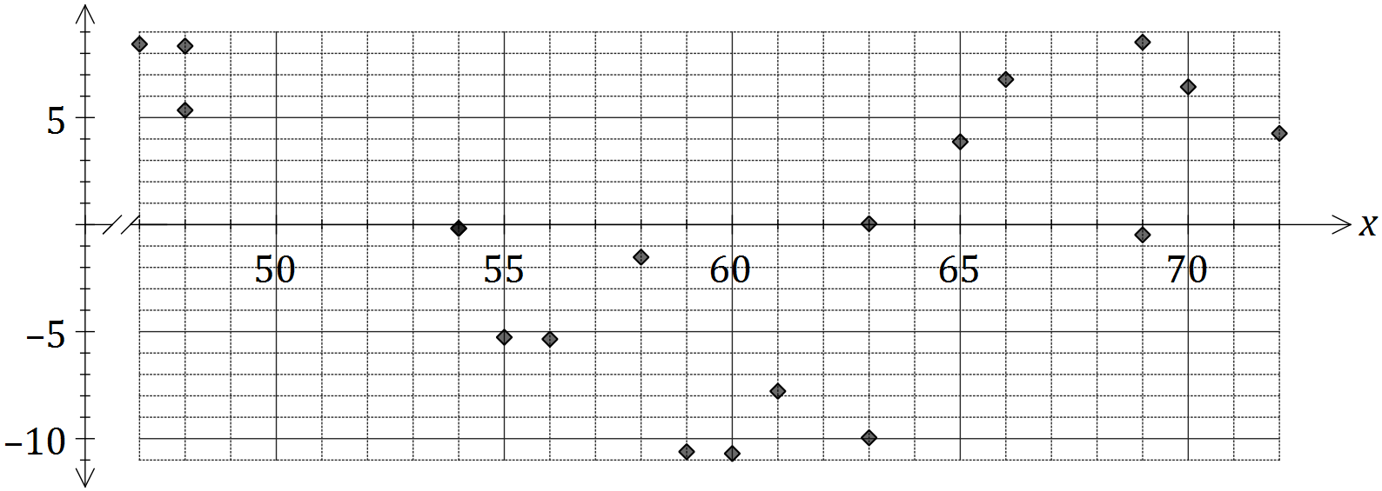

(a) Another student scored 52% in the biology test and 47% in the physics test. Calculate the residual for this student and plot it on the graph above. (3 marks)

(b) Use the residual plot to explain whether fitting a linear model to the data is appropriate.

(2 marks)

(c) What percentage of the variation in the physics scores can be explained by the variation in the biology scores? (2 marks)

(d) Are the variables and causally related? Explain your answer. (2 marks)

Additional working space

Question number: _________

Additional working space

Question number: _________

© 2017 WA Exam Papers. Kennedy Baptist College has a non-exclusive licence to copy and communicate this document for non-commercial, educational use within the school. No other copying, communication or use is permitted without the express written permission of WA Exam Papers. SN245-106-3.